## Requirement _UC01 - Add Requirement Use Case [UseCase ID – UseCase Full Name (use heading 2)]

### Class Diagram (use heading 3)

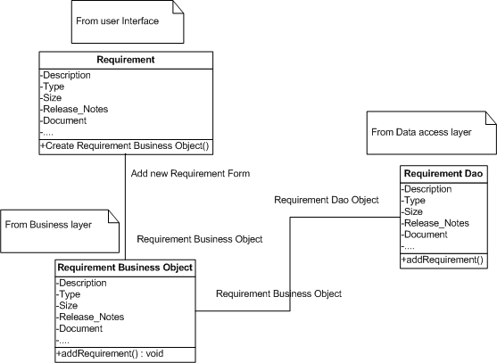

### Sequence flow (use heading 3)

